MYSQL BASIC : -------

**mysql> show databases;**

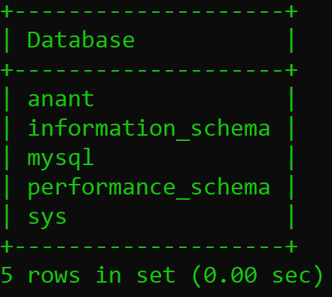

**mysql> drop database anant;**

Query OK, 0 rows affected (0.02 sec)

**mysql> create database anantdb;**

Query OK, 1 row affected (0.01 sec)

**mysql> show databases;**

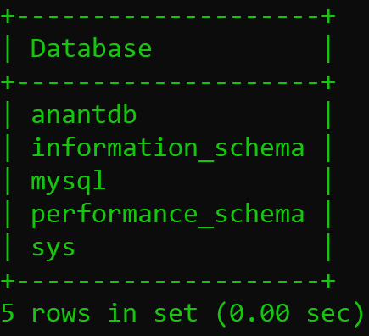

**mysql> use anantdb;**

Database changed

**mysql> create table details(id integer primary key,first_name varchar(20),name varchar(20),last_name varchar(20),proffession varchar(30),mobile_no integer(10),salary integer(10));**

Query OK, 0 rows affected, 2 warnings (0.02 sec)

**mysql> insert into details values(1,'soni','anant','rajeshkumar','web-developer',989658659,65000);**

Query OK, 1 row affected (0.01 sec)

**mysql> insert into details values(2,'rana','ashutosh','rameshkumar','app-developer',989658589,55000);**

Query OK, 1 row affected (0.01 sec)

**mysql> insert into details values(3,'patel','dhruv','sureshkumar','web-designer',989655589,45000);**

Query OK, 1 row affected (0.01 sec)

**mysql> insert into details values(4,'prajapati','kenil','dineshkumar','app-designer',989589589,58000);**

Query OK, 1 row affected (0.01 sec)

**mysql> insert into details values(5,'patel','kanu','ramalal','software-engineer',989578589,98000);**

Query OK, 1 row affected (0.01 sec)

**mysql> show tables;**

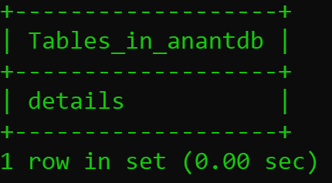

**mysql> desc details;**

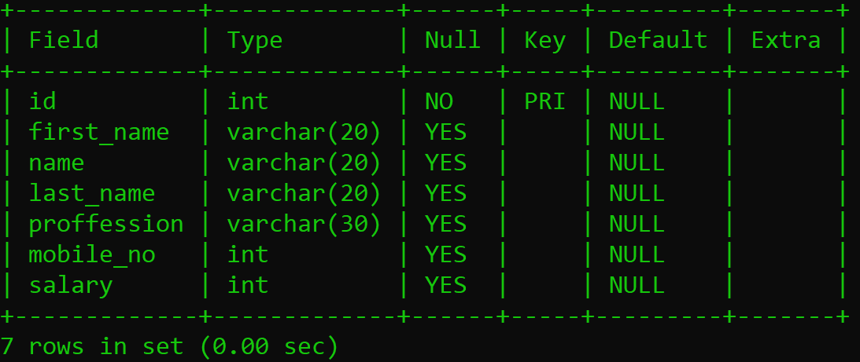

**mysql> select*from details;**

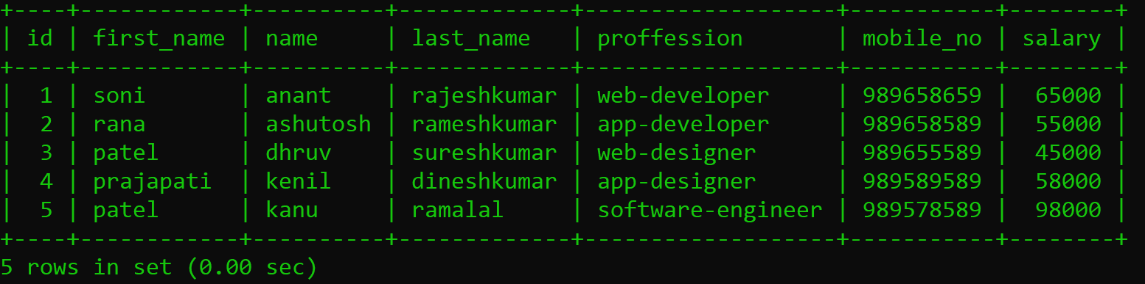

**mysql> alter table details add roll_no int(10);**

Query OK, 0 rows affected, 1 warning (0.03 sec)

Records: 0 Duplicates: 0 Warnings: 1

**mysql> select*from details;**

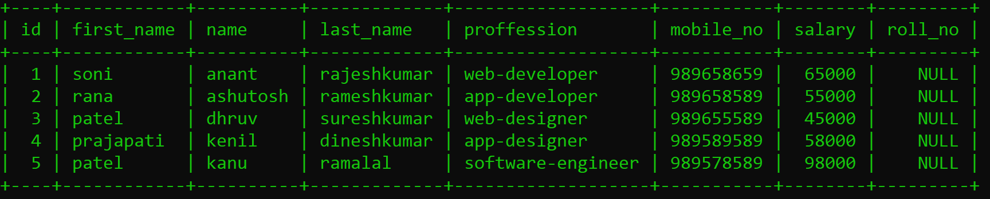

**mysql> alter table details drop column roll_no;**

Query OK, 0 rows affected (0.17 sec)

Records: 0 Duplicates: 0 Warnings: 0

**mysql> select*from details;**

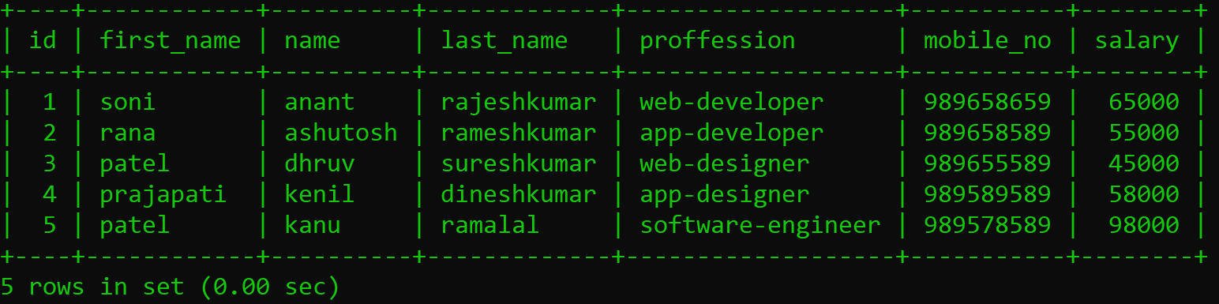

**mysql> drop database anantdb;**

Query OK, 1 row affected (0.02 sec)

**mysql> show databases;**

